The biography
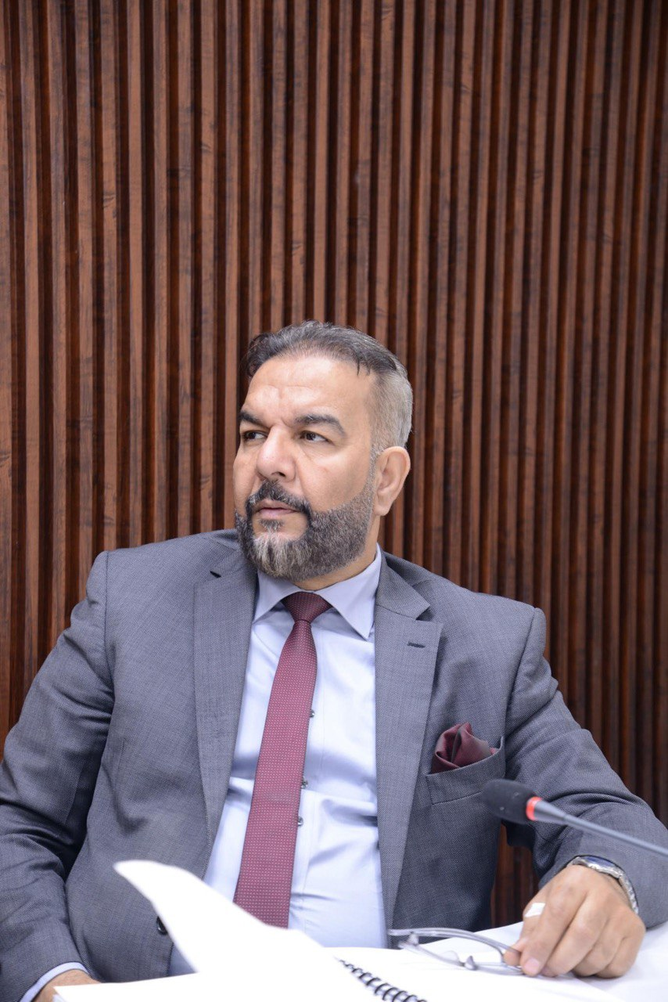
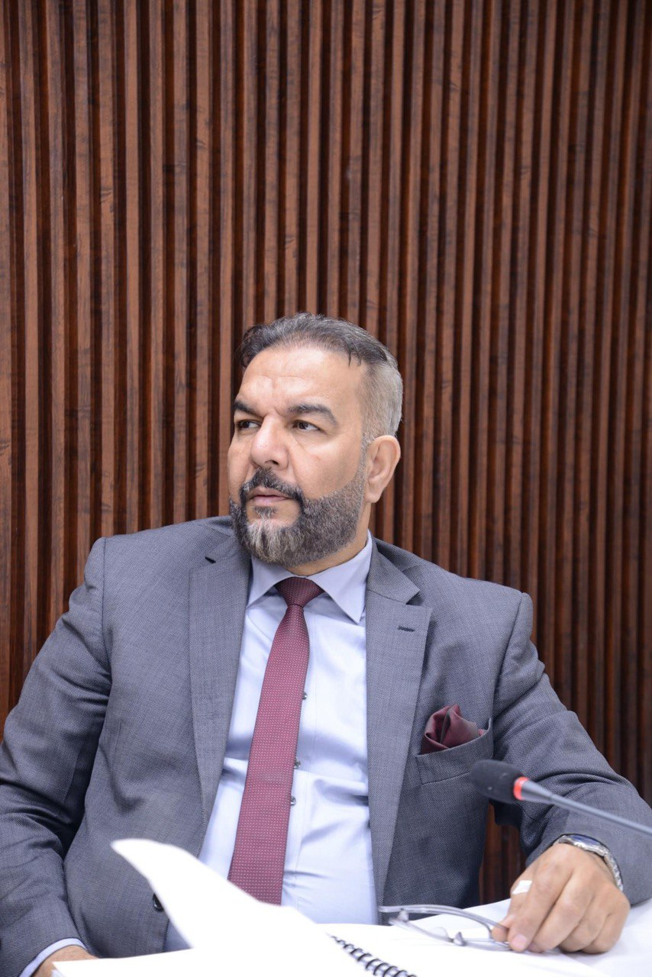

الصورة

Formation name: stitute of Genetic Engineering and Biotechnology for Postgraduate Studies, University of Baghdad
Name: and Rafid A Abdulkareem
Date of birth: Baghdad 1969
Scientific title: professor
General specialization: Biotechnology
Specialization: Genetic Engineering
Work address: Institute of Genetic Engineering and Biotechnology for Postgraduate Studies, University of Baghdad
Mobile phone: 07901473844
Email: rafid.a@ige.uobaghdad.edu.iq

First: Academic qualifications.
Date | College | University | Academic Degree University College Date
1993 | agriculture | Baghdad University | Bachelor
2002 | science | Baghdad University | Master
2013 | science | Baghdad University | PhD
 |  |  | Other

From - To | Title | Job | No.
- | - | - | -

Second: Job positions.

Third: Teaching efforts.
University/College/Department | Level | Subject Name | No.
Institute of Genetic Engineering | PhD | Cytogenetic | 1
Institute of Genetic Engineering | PhD | Advanced genetic engineering | 2
Institute of Genetic Engineering | Msc | Techniques in genetic engineering | 3
Institute of Genetic Engineering | Diploma | Genetic disease | 4
Institute of Genetic Engineering | Diploma | Genetic Engineering | 5

Fourth: Supervision of undergraduate and postgraduate students:
Number |  |  |  |  | No.
Undergraduate |  |  | Postgraduate |  | No.
 |  |  | 12 |  | 1
1 | . Pharmacogenetic Effect of Thiopurine Methyl Transferase (TPMT) Gene Expression and Serum TNF on the Imuran Response in Ulcerative Colitis | Romanian Journal of Infectious Diseases – Volume 27, No. 2, 2024 |  | shared
2 | Pharmacogenetic Effect of Thiopurine Methyl Transferase (TPMT) Gene Expression and Serum TNF on the Imuran Response in Ulcerative Colitis ( | Reports of Biochemistry & Molecular Biology Vol.12, No.3, Oct 2023 |  | shared
3 | Polymorphism (rs5049 G> A) of AGT Gene and Association with Hypertension Disease in Iraqi patients 2 1Genetic Engineering and Biotechnology | Acta Biomed 2023; Vol. 94, N. 2: e2023054 |  | shared
4 | Transferrin receptor 2 gene Expression and its influence on iron overload in patient with beta- thalassemia major in ALMuthana city A | Acta Biomed 2023; Vol. 94, N. 2: e2023092 |  | shared
5 | Elucidating novel antibacterial compounds from the NPASS database against the FimH lectin domain for the treatment of urinary tract infections: an in-silico study | journal of Biomolecular Structure and DynamicsThis link is disabled., 2023, 41(9), pp. 3914–3925 |  | shared
6 | PHARMACOGENETICS DRIVING PERSONALIZED MEDICINE: ANALYSIS OF GENETIC POLYMORPHISMS IN FCGR2A (RS1801274) AND ERBB2 (RS1136201) RELATED TO BREAST CANCER MEDICATIONS IN IRAQIS POPULATIONS | Hiv Nursing ,2022 |  | shared
7 | Association of C677T Single Nucleotide Polymorphism  of MTHFR with Susceptibility to Autism Spectrum  Disorders | Winter 2021, Volume 5, Issue 20 (9-11) |  | shared

Sixth: (Conferences, scientific seminars, workshops, study groups, social activities, etc.)

ت | العنوان | السنــة | مكان أنعقادها | نوع المشاركة  ( بحث / بوستر حضور)
1 | The 3ed Scientific International Conference of the Institute for Genetic Engineering (Molecular diagnosis of cancer disease and role in treatment methods development) | 25-26/10/2017 | Baghdad university | Research
2 | The 4ed Scientific International Conference of the Institute for Genetic Engineering of Biotechnology Towards a new Horizon | 29-30/4/2019 | Baghdad university university | Research
3 | APCBEES/IEDRC CONFERENCE  ABSTRACT | July 7-9, 2016 | shanghai university | Research
4 | The 2ed Scientific and 1st International Conference of applicable researches and the Patents 9-11/4/2019 Middle Technical University / College of Health and Medical Technology /  Baghdad | 9-11/4/2019 | Middle Technical University / | Attendance
5 | Third Scientific Conference of the Faculty of Veterinary  Medicine 18-19/10/2016 | 2016 | Alkufa university | Research

Seventh: The training courses
Place | (Research/  Attendance Poster) | Type of participation | Year | Title | No.
College of science |  | Attendance | 2018 | PCR traning | 1
College of Administration and Economics |  | Attendance | 2021 | Strategic planning | 2
Institute of Genetic Engineering |  | Attendance | 2024 | Importance of PCR | 3

Eighth: Chairmanship and membership of committees.
Date | The Committee Name
2023 | Member of drug control
2023 | Ministry Member of PhD study opining
2017-2023 | Member of Examining Committee for many Higher diploma &  Master Students &Ph.D.

Ninth: Authored or translated books.
Year of publication | Name of Book | No.
2013 | Cloning and Expression of Human Insulin Gene in baking yeast | 1
2017 | Computitional Preduction of Toxicity of Fermentation Products | 2
2018 | Bioethanol production from waste office paper by using microorganism | 3

Tenth: (Thanking letters and certificates of appreciation).
Other | Director General | Dean of the College | University President Assistants | University President | Deputy Minister | Minister | Number of thanking and appreciation letters | No
 |  | 7 | 3 | 8 | 4 | 5 | Number of thanking and appreciation letters

Eleven: (Prizes).
Year | Donor | Awards | No.
- | - | - | -

Twelve: Languages.
- English

